**OFFICIAL COORDINATION REQUEST FOR**

**NON-ROUTINE OPERATIONS AND MAINTENANCE**

**COORDINATION TITLE-** 24JDA01 – SFL 2-Fish Turbine Operation and Floating Orifice Gate Removals

**COORDINATION DATE-** 1/31/24

**PROJECT-** John Day Dam

**RESPONSE DATE- 2/15/2024**

**Description of the problem -** The John Day South (JD-S) fishway has an auxiliary water supply powered by three turbines which feeds water to the entrance area of the JD-S fish ladder. Each turbine design is complex and consists of a turbine, gear box, and the pump itself.

During the 2023 winter maintenance season, metal shavings were found in south fish turbine (SFT) #3 that required major gearbox repairs (as of 1/30/24 repairs are still underway, and repairs are anticipated to be completed by 1 March 2024). Additionally, on 1 March 2023, excessive vibrations, due to worn guide bearings, were noticed at SFT #2 (SFT #1 has a similar issue). To preserve the life of SFT #1&2, personnel opted to run them at reduced RPMs (55 RPMs instead of the usual 68 RPMs) in 2023.

Currently, SFT #1&2 are in the planning phase of major overhauls, therefore acquiring significant funding at this time which is underway.

Two JD-S SFT’s, running at max RPMs (68-RPMs), are required to meet FPP criteria, with one remaining as a back-up. The FPP provides operational guidance for AWS turbine failures. With SFTs #1&2 running at reduced RPMs, SFT #3 (when repairs are completed) will operate at max RPMs, and either SFT #1 or #2 will operate at reduced RPMs (while the other acts as a backup).

The FPP states “if one turbine fails, increase the output of the two remaining turbines to meet adult fishway criteria” (3.2.4.1.a.). Since SFT #3 will already be running at max RPMs and the other SFT can only be run at reduced RPMs, this will not be possible. Therefore, personnel are requesting to operate JD-S in a modified 1-turbine operation (3.2.4.1.b). All entrance weirs will be open at 8’ (instead of closing NE-1), and the floating submerged orifice gates (FOGs) will be closed. This should allow for adequate attraction flow to the JD-S while also leaving one SFT available for backup.

**Type of outage required – FOGs** will be removed for 2024 similar to the 2023 adult passage season. The additional water savings will aid in decreasing the output of SFT 1 or 2 and will help by decreasing any degradation to the unit’s pump assemblies, which are in poor shape and at risk of total failure.

**Impact on facility operation –** There will be minimal impacts to facility operation. However, removing the FOGs will allow the remaining JD-S entrances to run in criteria while also freeing up one of the turbines as a backup.

**Dates of impacts/repairs –** 1 March 2024 – 11 November 2024

**Length of time for repairs** – Unknown, as stated earlier SFT #1 & #2 are in the planning phase of a major overhaul with no set repair dates.

**Analysis of potential impacts to fish-**

None- Mean travel time for Spring migrants was similar between 2022 and 2023.

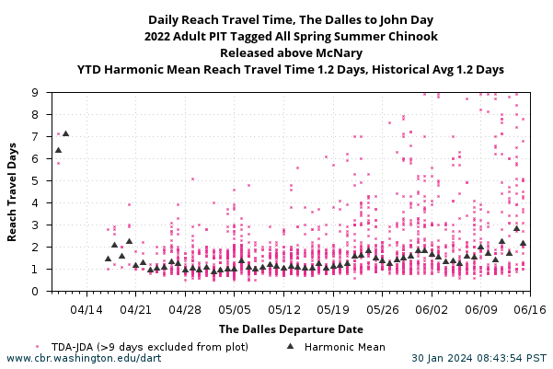

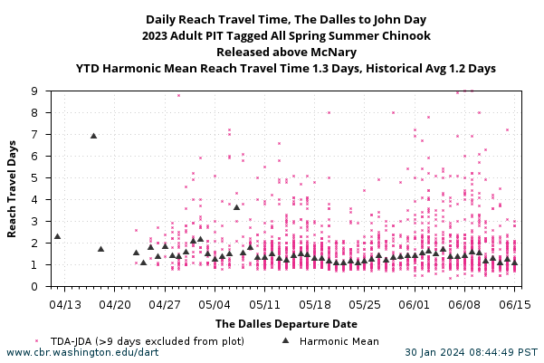

**Summary statement – expected impacts on:**

**Downstream migrants:** There is no expected impact to downstream migrants.

**Upstream migrants (including Bull Trout):** The entrance weirs and their entrances will be kept in FPP ranges.

**Lamprey:** The entrance weirs and their entrances will be kept in FPP ranges.

**The condition of South fish turbine pumps 1 & 2 gives the project no flexibility in maintaining entrance criteria at the ladder entrances if the floating orifices are redeployed.**

**Comments from agencies**

**Final coordination results**

Please email or call with questions or concerns.

Thank you,

Eric Grosvenor

Supervisory Fish Biologist

[Eric.Grosvenor@usace.army.mil](mailto:Eric.Grosvenor@usace.army.mil)

Patricia Madson

Columbia River Coordinator (acting)

[patricia.l.madson@usace.army.mil](mailto:patricia.l.madson@usace.army.mil)